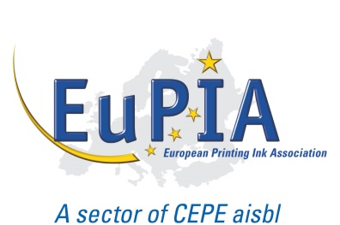
Company Logo

Commitments

related to the manufacture and supply of food packaging inks

Company name, being a member of EuPIA, has committed to the following principles in order to safeguard the protection of food consumer safety within the areas under its control.

These commitments, to be applied by each company in the way it decides appropriate, cover all products manufactured or marketed for application to the non-food contact surface of food packaging materials and articles.

We are committed to:
- the principle of placing consumer safety first;
- compliance with relevant legislation currently in force and the resultant legal requirements in order to ensure a high level of consumer safety;
- the principles of transparency and information sharing to enable compliance within the packaging supply chain, whilst preserving appropriate commercial confidentiality and respecting competition law rules;
- the supply of products fit for the intended purpose as mutually defined between each company and its customers;
- the concept of risk and exposure assessment in accordance with internationally recognized scientific principles;
- the principles and implementation of Good Manufacturing Practices, including audit processes;
- the principle of continuous improvement in consumer safety in the light of any new scientific findings; and
- following EuPIA crisis management procedures, or equivalents, in the event of an incident related to a food packaging ink.

Company: Date: Signature:

